Student: Brian Johnston

Class COP 2362

Assignment 5-2

Print screens: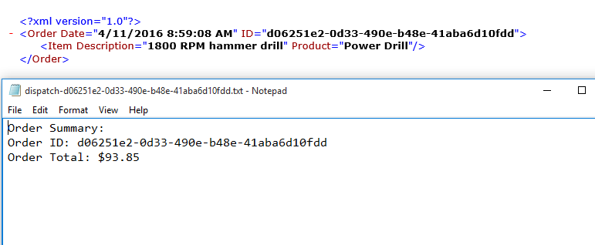

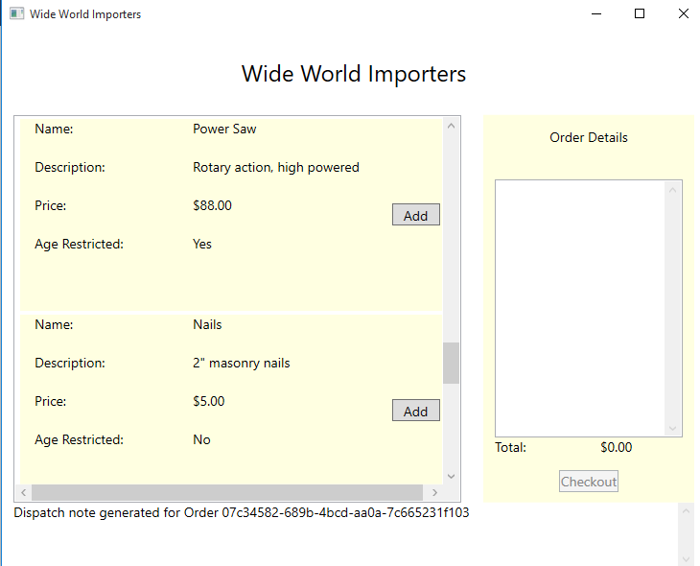

namespace CheckoutService

{

public class CheckoutController

{

//Used to reference methods that take an Order param and does not return a result

public delegate void CheckoutDelegate(Order order);

public CheckoutDelegate CheckoutProcessing = null;

private bool requestPayment()

{

// Payment processing goes here

// Payment logic is not implemented in this example

// - simply return true

return true;

}

public void StartCheckoutProcessing(Order order)

{

//Perform the checkout processing

if (this.requestPayment())

{

if (this.CheckoutProcessing != null)

{

this.CheckoutProcessing(order);

}

}

}

}

}